UNIT 5:
Emotional Wellbeing
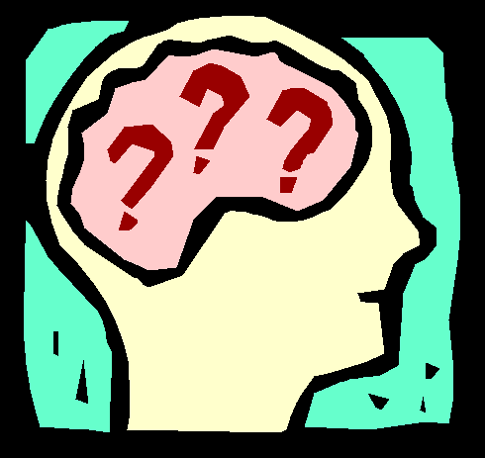

Level 2

Name…………………………………………
Class..………………………………………...
Teacher………………………………………

Assessment Criteria for Emotional Wellbeing Unit 5:

Learning outcomes  The Learner will: | Assessment Criteria  The Learner can:
1. Understand possible causes of stress | 1.1 Describe at least three causes of stress  1.2 Explain why each cause might result in stress for an individual
2. Know possible effects of stress | 2.1 List the main effects of stress  2.2 Describe briefly each effect using examples where possible
3. Know about how stress can be managed | 3.1 Describe at least three stress management techniques and explain how each may be of benefit
4. Understand the meaning and causes of prejudice | 4.1 Define what is meant by prejudice  4.2 Describe four forms of prejudice  4.3 Explain three causes of prejudice
5. Know about the consequences of prejudice | 5.1 Describe three consequences of prejudice using examples
6. Understand the meaning of equal opportunities | 6.1 Explain what is meant by “equal opportunities”  6.2 Describe three instances of equal opportunities either being provided or being denied
7. Understand the nature of bullying and how to deal with it | 7.1 Describe at least three examples of bullying explaining why each occurs  7.2 Describe in detail two ways of dealing with bullying
8. Know about the nature of a selected mental illness and how it may be treated | 8.1 Describe the nature and treatment of one mental illness  8.2 Outline the support offered by a specialised agency dealing with this illness

Teacher Feedback

Assessment Criteria | Complete | Comments
1.1
1.2
2.1
2.2
3.1
4.1
4.2
4.3
5.1
6.1
6.2
7.1

7.2

8.1

8.2

1. Understand possible causes of stress

1.1 Describe at least three causes of stress

1. ________________________________________________________________________________________________________________________________________________________________________________________________________________________________________________________________________________________________________________________________________________________________________________________________________________________________________________________________________________________________________________________________________________________________________________________________________________________________________________________________________________________________________________________________________

2. ________________________________________________________________________________________________________________________________________________________________________________________________________________________________________________________________________________________________________________________________________________________________________________________________________________________________________________________________________________________________________________________________________________________________________________________________________________________________________________________________________________________________________________________________________

3. ________________________________________________________________________________________________________________________________________________________________________________________________________________________________________________________________________________________________________________________________________________________________________________________________________________________________________________________________________________________________________________________________________________________________________________________________________________________________________________________________________________________________________________________________________
1.2 Explain why each cause might result in stress for an individual

1. ________________________________________________________________________________________________________________________________________________________________________________________________________________________________________________________________________________________________________________________________________________________________________________________________________________________________________________________________________________________________________________________________________________________________________________________________________________________________________________________________________________________________________________________________________

2. ________________________________________________________________________________________________________________________________________________________________________________________________________________________________________________________________________________________________________________________________________________________________________________________________________________________________________________________________________________________________________________________________________________________________________________________________________________________________________________________________________________________________________________________________________

3. ________________________________________________________________________________________________________________________________________________________________________________________________________________________________________________________________________________________________________________________________________________________________________________________________________________________________________________________________________________________________________________________________________________________________________________________________________________________________________________________________________________________________________________________________________
2. Know possible effects of stress

Outcome 2.1 List the main effects of stress; 2.2 Describe briefly each effect using examples where possible

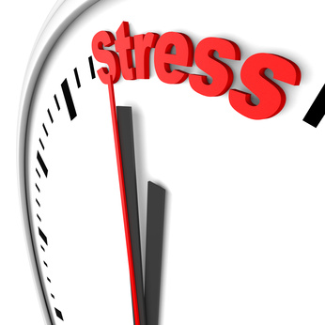

Symptom | Description of Effects
3. Know about how stress can be managed

Outline 3.1 Describe at least three stress management techniques and explain how each may be of benefit

Technique:

How it helps:

Technique:

How it helps:

Technique:

How it helps:

4. Understand the meaning and causes of prejudice
&
5. Know about the consequences of prejudice

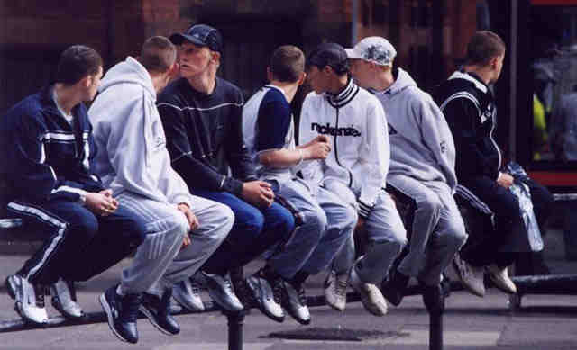

Outcome 4.1 Define what is meant by prejudice; 4.2 Describe four forms of prejudice

Outcome 4.3 Explain three causes of prejudice

1. ________________________________________________________________________________________________________________________________________________________________________________________________________________________________________________________________________________________________________________________________________________________________________________________________________________________________________________________________________________________________________________________________________________________________________________________________________________________________________________________________________________________________________________________________________

2. ________________________________________________________________________________________________________________________________________________________________________________________________________________________________________________________________________________________________________________________________________________________________________________________________________________________________________________________________________________________________________________________________________________________________________________________________________________________________________________________________________________________________________________________________________

3. ________________________________________________________________________________________________________________________________________________________________________________________________________________________________________________________________________________________________________________________________________________________________________________________________________________________________________________________________________________________________________________________________________________________________________________________________________________________________________________________________________________________________________________________________________
Outcome 5.1 Describe three consequences of prejudice using examples

1. ________________________________________________________________________________________________________________________________________________________________________________________________________________________________________________________________________________________________________________________________________________________________________________________________________________________________________________________________________________________________________________________________________________________________________________________________________________________________________________________________________________________________________________________________________

2. ________________________________________________________________________________________________________________________________________________________________________________________________________________________________________________________________________________________________________________________________________________________________________________________________________________________________________________________________________________________________________________________________________________________________________________________________________________________________________________________________________________________________________________________________________

3. ________________________________________________________________________________________________________________________________________________________________________________________________________________________________________________________________________________________________________________________________________________________________________________________________________________________________________________________________________________________________________________________________________________________________________________________________________________________________________________________________________________________________________________________________________
6. Understand the meaning of equal opportunities

Outcome 6.1 Explain what is meant by “equal opportunities”

________________________________________________________________________________________________________________________________________________________________________________________________________________________________________________________________________________________________________________________________________________________________________________________________________________________________________________________________________________________________________________________________________________________________________________________________________________________________________________________________________________

Outcome 6.2 Describe three instances of equal opportunities either being provided or being denied

- ________________________________________________________________________________________________________________________________________________________________________________________________________________________________________________________________________________________________________________________________________________________________________________________________________________________________________________________________________________________________________________________________________________________________________________________________________________________________________________________________________________________________________________________________________

- ________________________________________________________________________________________________________________________________________________________________________________________________________________________________________________________________________________________________________________________________________________________________________________________________________________________________________________________________________________________________________________________________________________________________________________________________________________________________________________________________________________________________________________________________________

- ________________________________________________________________________________________________________________________________________________________________________________________________________________________________________________________________________________________________________________________________________________________________________________________________________________________________________________________________________________________________________________________________________________________________________________________________________________________________________________________________________________________________________________________________________

7. Understand the nature of bullying and how to deal with it

Outcome 7.1 Describe at least three examples of bullying explaining why each occurs

Example:

Why it occurs:

Example:

Why it occurs:

Example:

Why it occurs:

Outcome 7.2 Describe in detail two ways of dealing with bullying

__________________________________________________________________________________________________________________________________________________________________________________
___________________________________________________________________________________________________________________________________________________________________________________________________________________________________________________________________________________________________________________________________________________________________________________________________________________________________________________________________________________________________________________________________________________________________________________________________________________________________________________________________________________________________________________________________________________________________________________________________________________________________________________________________________________________________________________________________________________________________________________________________________________

__________________________________________________________________________________________________________________________________________________________________________________
___________________________________________________________________________________________________________________________________________________________________________________________________________________________________________________________________________________________________________________________________________________________________________________________________________________________________________________________________________________________________________________________________________________________________________________________________________________________________________________________________________________________________________________________________________________________________________________________________________________________________________________________________________________________________________________________________________________________________________________________________________________

8. Know about the nature of a selected mental illness and how it may be treated

Outcome 8.1 Describe the nature and treatment of one mental illness

The Nature of:
__________________________________________________________________________________________________________________________________________________________________________________
___________________________________________________________________________________________________________________________________________________________________________________________________________________________________________________________________________________________________________________________________________________________________________________________________________________________________________________________________________________________________________________________________________________________________________________________________________________________________________________________________________________________________________________________________________________________________________________________________________________________________________________________________________________________________________________________________________________________________________________________________________________

The treatment of:

__________________________________________________________________________________________________________________________________________________________________________________
___________________________________________________________________________________________________________________________________________________________________________________________________________________________________________________________________________________________________________________________________________________________________________________________________________________________________________________________________________________________________________________________________________________________________________________________________________________________________________________________________________________________________________________________________________________________________________________________________________________________________________________________________________________________________________________________________________________________________________________________________________________

Outcome 8.2 Outline the support offered by a specialised agency dealing with this illness

__________________________________________________________________________________________________________________________________________________________________________________
___________________________________________________________________________________________________________________________________________________________________________________________________________________________________________________________________________________________________________________________________________________________________________________________________________________________________________________________________________________________________________________________________________________________________________________________________________________________________________________________________________________________________________________________________________________________________________________________________________________________________________________________________________________________________________________________________________________________________________________________________________________
___________________________________________________________________________________________________________________________________________________________________________________________________________________________________________________________________________________________________________________________________________________________________________________________________________________________________________________________________________________________________________________________________________________________________________________________________________________________________________________________________________________________________________________________________________________________________________________________________________________________________________________________________________________________________________________________________________________________________________________________________________________

