UNIT 10:
Personal Safety
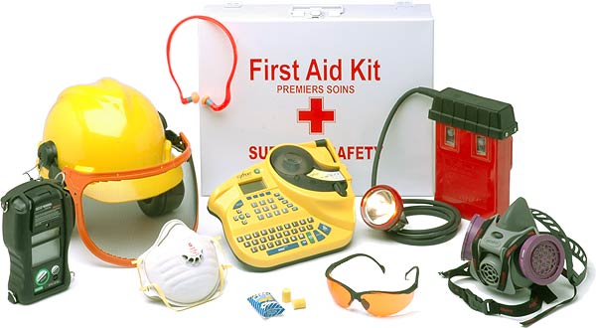

Level 2

Name…………………………………………
Group………………………………………
Teacher………………………………………

Personal Safety Criteria:

Learning outcomes  The learner will: | Assessment Criteria  The learner can:
1. Know how to identify dangers in a variety of situations and how to avoid them | 1.1 Identify three potential dangers in each of: a home; a work place; a learning environment  1.2 Explain why each of the identified dangers is a threat  1.3 Describe one way in which each threat could be avoided  1.4 Carry out a risk assessment for own home  1.5 Produce a plan to evacuate own household in case of a fire  1.6 Explain why someone might not respond positively to risk, e.g. not fit a smoke alarm
2. Know about the extent and limitation of personal responsibility for safety | 2.1 Describe two areas where an individual is responsible for his/her own safety  2.2 Describe two areas where the state imposes safety on the individual, e.g. seat belts, air travel  2.3 Explain why the state might legislate in areas of personal safety
3. Know about the dangers to personal safety when using modern communication technology | 3.1 Identify two social network sites and their age restrictions  3.2 Explain at least two potential dangers of social networking sites  3.3 Explain one threat to an individual if personal information is disclosed when using modern technology  3.4 Describe at least one method that can be used to protect personal information when using modern technology  3.5 Describe what cyber bullying is and where support can be obtained for a victim of it
4. Know about an organisation that provides advice on personal safety other than in the area of modern technology | 4.1 Describe the support available from an organisation that gives advice on personal safety other than in the area of modern technology

Teacher Feedback

Assessment Criteria | Complete | Comments
1.1
1.2
1.3
1.4
1.5
1.6
2.1
2.2
2.3
3.1
3.2
3.3
3.4

3.5

4.1

1. Know how to identify dangers in a variety of situations and how to avoid them

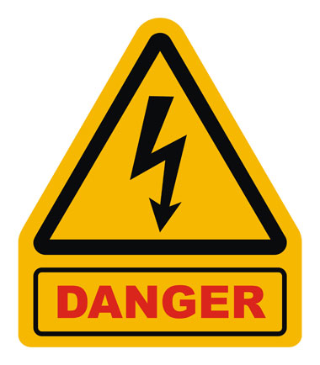

  - Identify three potential dangers in each of: a home; a work place; a learning environment
1.2 Explain why each of the identified dangers is a threat
1.3 Describe one way in which each threat could be avoided

- Danger: ________________________________________________________________________________________________________________________________________________________________________________________________________________________________________________________________________

Why it’s a threat: ________________________________________________________________________________________________________________________________________________________________________________________________________________________________________________________________________

Avoided:
________________________________________________________________________________________________________________________________________________________________________________________________________________________________________________________________________

- Danger: ________________________________________________________________________________________________________________________________________________________________________________________________________________________________________________________________________

Why it’s a threat: ________________________________________________________________________________________________________________________________________________________________________________________________________________________________________________________________________

Avoided:
________________________________________________________________________________________________________________________________________________________________________________________________________________________________________________________________________
- Danger: ________________________________________________________________________________________________________________________________________________________________________________________________________________________________________________________________________

Why it’s a threat: ________________________________________________________________________________________________________________________________________________________________________________________________________________________________________________________________________

Avoided:
________________________________________________________________________________________________________________________________________________________________________________________________________________________________________________________________________

1.Danger: ________________________________________________________________________________________________________________________________________________________________________________________________________________________________________________________________________

Why it’s a threat: ________________________________________________________________________________________________________________________________________________________________________________________________________________________________________________________________________

Avoided:
________________________________________________________________________________________________________________________________________________________________________________________________________________________________________________________________________

2.Danger: ________________________________________________________________________________________________________________________________________________________________________________________________________________________________________________________________________

Why it’s a threat: ________________________________________________________________________________________________________________________________________________________________________________________________________________________________________________________________________

Avoided:
___________________________________________________________________________________________________________________________________________________________________________________________________________________________________________________________________________
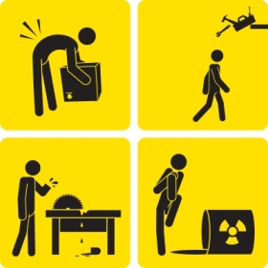

3.Danger: ________________________________________________________________________________________________________________________________________________________________________________________________________________________________________________________________________

Why it’s a threat: ________________________________________________________________________________________________________________________________________________________________________________________________________________________________________________________________________

Avoided:
________________________________________________________________________________________________________________________________________________________________________________________________________________________________________________________________________

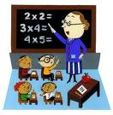

1.Danger: ________________________________________________________________________________________________________________________________________________________________________________________________________________________________________________________________________

Why it’s a threat: ________________________________________________________________________________________________________________________________________________________________________________________________________________________________________________________________________

Avoided:
________________________________________________________________________________________________________________________________________________________________________________________________________________________________________________________________________
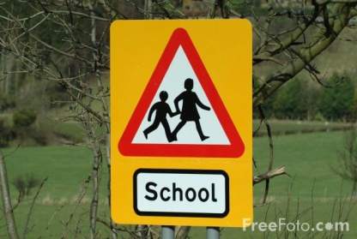

2.Danger: ________________________________________________________________________________________________________________________________________________________________________________________________________________________________________________________________________

Why it’s a threat: ________________________________________________________________________________________________________________________________________________________________________________________________________________________________________________________________________

Avoided:
___________________________________________________________________________________________________________________________________________________________________________________________________________________________________________________________________________
3.Danger: ________________________________________________________________________________________________________________________________________________________________________________________________________________________________________________________________________

Why it’s a threat: ________________________________________________________________________________________________________________________________________________________________________________________________________________________________________________________________________

Avoided:
________________________________________________________________________________________________________________________________________________________________________________________________________________________________________________________________________

1.4 Carry out a risk assessment for own home

Risk Assessment
Date:

Site | Risk? | How this is solved?
Outside space / garden
Kitchen
Lounge
Stairs / Hall
Bathroom
Bedroom
Other:
1.5 Produce a plan to evacuate own household in case of a fire

Draw a layout of your house and mark on all the fire escape routes from every room.

1.6 Explain why someone might not respond positively to risk, e.g. not fit a smoke alarm

__________________________________________________________________________________________________________________________________________________________________________________________________________________________________________________________________________________________________________________________________________________________________________________________________________________________________________________________________________________________________________________________________________________________________________________________________________________________________________________________________________________________________________________________________________________________________________________________________________________________________________________________________________________

2. Know about the extent and limitation of personal responsibility for safety

2.1 Describe two areas where an individual is responsible for his/her own safety

1.
______________________________________________________________________________________________________________________________________________________________________________________________________________________________________________________________________________________________________________________________________________________________________________________________________________________________________________________________________________________________________________________________________________________________________________________________________________________________________________________________________________________________________________________________________________________________________________________________________________________________________________________________________________________________________________________________________________________________________________________________________________________________________________________________________________________________________________________________________________________________________________________________________________________________________

2.
______________________________________________________________________________________________________________________________________________________________________________________________________________________________________________________________________________________________________________________________________________________________________________________________________________________________________________________________________________________________________________________________________________________________________________________________________________________________________________________________________________________________________________________________________________________________________________________________________________________________________________________________________________________________________________________________________________________________________________________________________________________________________________________________________________________________________________________________________________________________________________________________________________________________________

2.2 Describe two areas where the state imposes safety on the individual, e.g. seat belts, air travel

1.
_________________________________________________________________________________________________________________________________________________________________________________________________________________________________________________________________________________________________________________________________________________________________________________________________________________________________________________________________________________________________________________________________________________________________________________________________________________________________________________________________________________________________________________________________________________________________________________________________________________________________________________________________________________________________________________________________________________________________________________________________________________________________________________________________________________________________________________________________________________

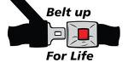
2.
_________________________________________________________________________________________________________________________________________________________________________________________________________________________________________________________________________________________________________________________________________________________________________________________________________________________________________________________________________________________________________________________________________________________________________________________________________________________________________________________________________________________________________________________________________________________________________________________________________________________________________________________________________________________________________________________________________________________________________________________________________________________________________________________________________________________________________________________________________________

2.3 Explain why the state might legislate in areas of personal safety

______________________________________________________________________________________________________________________________________________________________________________________________________________________________________________________________________________________________________________________________________________________________________________________________________________________________________________________________________________________________________________________________________________________________________________________________________________________________________________________________________________________________________________________________________________________________________________________________________________________________________________________________________________________________________________________________________________________________________________________________________________________________________________________________________________________________________________________________________________________________________________________________________________________________________________________

3. Know about the dangers to personal safety when using modern communication technology

  - Identify two social network sites and their age restrictions

Social network site 1:

Age restriction:

Social network site 2:

Age restriction:

  - Explain at least two potential dangers of social networking sites

Danger 1: ________________________________________________________________________________________________________________________________________________________________________________________________________________________________________________________________________________________________________________________________________________________________________________________________________________________________________________________________________________________________________________________________________________________________________________________________________________________________________________________________________________________________________

Danger 2: ________________________________________________________________________________________________________________________________________________________________________________________________________________________________________________________________________________________________________________________________________________________________________________________________________________________________________________________________________________________________________________________________________________________________________________________________________________________________________________________________________________________________________

  - Explain one threat to an individual if personal information is disclosed when using modern technology

________________________________________________________________________________________________________________________________________________________________________________________________________________________________________________________________________________________________________________________________________________________________________________________________________________________________________________________________________________________________________________________________________________________________________________________________________________________________________________________________________________________________________

  - Describe at least one method that can be used to protect personal information when using modern technology

________________________________________________________________________________________________________________________________________________________________________________________________________________________________________________________________________________________________________________________________________________________________________________________________________________________________________________________________________________________________________________________________________________________________________________________________________________________________________________________________________________________________________

  - Describe what cyber bullying is and where support can be obtained for a victim of it

What is cyber bullying?
___________________________________________________________________________________________________________________________________________________________________________________________________________________________________________________________________________________________________________________________________________________________________________________________________________________________________________________________________________________________________________________________________________________________________________________________________________________

Where can you get support for this?
_________________________________________________________________________________________________________________________________________________________________________________________________________________________________________________________________________________________________________________________________________________________________________________________________________________________________________________________________________________________________________________________________________________________________________________________________________________________________________________________________________________________________________________________________________________________________________________________________________________________________________________________________________________________________________________________________________________________________________________________________________________________________________________________________________________________________________________________________________________

4. Know about an organisation that provides advice on personal safety other than in the area of modern technology

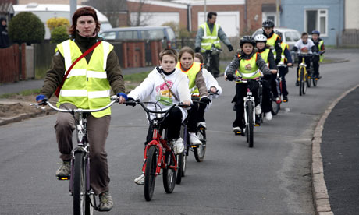

4.1 Describe the support available from an organisation that gives advice on personal safety other than in the area of modern technology

________________________________________________________________________________________________________________________________________________________________________________________________________________________________________________________________________________________________________________________________________________________________________________________________________________________________________________________________________________________________________________________________________________________________________________________________________________________________________________________________________________________________________
___________________________________________________________________________________________________________________________________________________________________________________________________________________________________________________________________________________________________________________________________________________________________________________________________________________________________________________________________________________________________________________________________________________________________________________________________________________

